**Computer Vision**



**Face identification and Capture for Automated Attendance System**

**Submitted By:**

Muhammad Bin Nasir 220201012

Aiza Shafqat 220201036

Baseerat Nadeem 220201027

**Submitted To:**

Ms. Natiqa Gull

**Department of Computer Science**

**Institute of Space Technology**

Catalog

1. Introduction 3

2. System Overview 3

2.1 Key Features 3

2.2 Technology Stack 3

3. System Components 3

3.1 Face Detection and Recognition 3

3.2 Real-Time Processing 3

3.3 Anti-Spoofing Mechanism 4

3.4 Attendance Marking 4

3.5 GUI Interface 4

4. Working Principle 4

1. Initialization: 4

2. Webcam Capture: 4

3. Face Detection & Encoding: 4

4. Recognition: 4

5. Anti-Spoofing: 4

6. Attendance Logging: 4

5. Limitations 5

6. Future Improvements 5

7. Conclusion 5

8. References 5

9. Screenshots 5

## 1. Introduction

The Face Recognition Attendance System with Anti-Spoofing is an intelligent attendance marking system that identifies individuals using facial features captured via webcam. The system also integrates anti-spoofing mechanisms to prevent fraudulent attendance using photos or videos. Attendance records are maintained in an Excel file for easy accessibility and review.

## 

## 2. System Overview

### 2.1 Key Features

* Real-Time Face Detection
* Face Recognition (using pre-trained models)
* Anti-Spoofing (3D Face Mesh Detection)
* Excel-based Attendance Logging
* GUI-based Face Add/Remove Functionality (PyQt6)

### 2.2 Technology Stack

* Programming Language: Python 3.10
* Libraries Used:
  + OpenCV
  + face_recognition (dlib-based)
  + MediaPipe (for anti-spoofing)
  + PyQt6 (GUI)
  + pandas, openpyxl (Excel operations)

## 

## 3. System Components

### 3.1 Face Detection and Recognition

* The system loads known face images from the known_faces/ directory.
* Each image is processed to extract a 128-dimensional face encoding using dlib’s ResNet34 pre-trained model via the face_recognition library.
* These encodings form the known dataset against which real-time webcam faces are compared.

### 3.2 Real-Time Processing

* Webcam feed is continuously read.
* Each frame is resized and encoded.
* Face recognition is performed by comparing the real-time encoding with the known encodings using Euclidean distance.

### 3.3 Anti-Spoofing Mechanism

* MediaPipe’s Face Mesh solution checks the presence of facial landmarks in 3D space.
* Ensures that the face is real (not a photo or video).

### 3.4 Attendance Marking

* Upon successful recognition and anti-spoofing validation, the person’s name and current timestamp are recorded in an Excel file (attendance.xlsx).
* Each day has a separate sheet named after the date (e.g., ‘2025-06-10’).

### 3.5 GUI Interface

* Developed using PyQt6.
* Features:
  + Start/Stop Attendance
  + Add New Face (via webcam capture)
  + Remove Existing Face
* Password-protected administrative actions to prevent unauthorized modifications.

## 

## 4. Working Principle

1. Initialization:
   * Load known faces and encodings from the disk.
2. Webcam Capture:
   * Stream real-time video.
3. Face Detection & Encoding:
   * Detect and encode face into a feature vector.
4. Recognition:
   * Compare with the stored face encodings.
5. Anti-Spoofing:
   * Check for 3D facial landmarks using MediaPipe.
6. Attendance Logging:
   * Mark attendance in Excel if all checks pass.

## 

## 5. Limitations

* Requires proper lighting for optimal detection.
* Can misidentify faces if the database images are poor quality.
* Relies on MediaPipe’s facial landmark model for anti-spoofing — extreme angles or occlusions may reduce effectiveness.

## 

## 6. Future Improvements

* Integration of Deep Learning-based anti-spoofing.
* Cloud database for attendance records.
* Mobile application interface.
* Live notification/email system.

### 

## 7. Conclusion

This project successfully demonstrates an efficient, real-time Face Recognition Attendance System with Anti-Spoofing capabilities and user-friendly GUI. It ensures secure and automated attendance marking suitable for academic and corporate environments.

### 

## 8. References

* https://pypi.org/project/face-recognition/
* https://google.github.io/mediapipe/
* https://pypi.org/project/pyqt6/
* https://pandas.pydata.org/
* https://openpyxl.readthedocs.io/

### 

## 9. Screenshots

* Figure 1: Main GUI Window

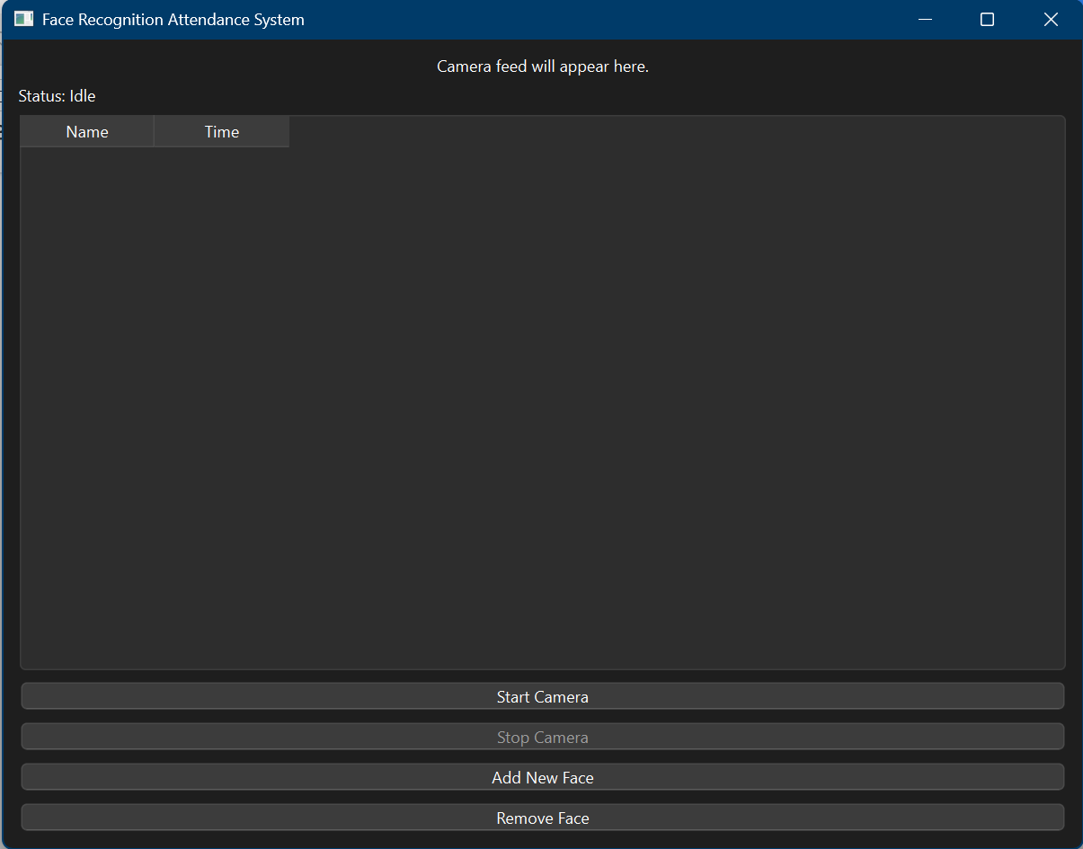

* Figure 2: Face Recognition in Progress

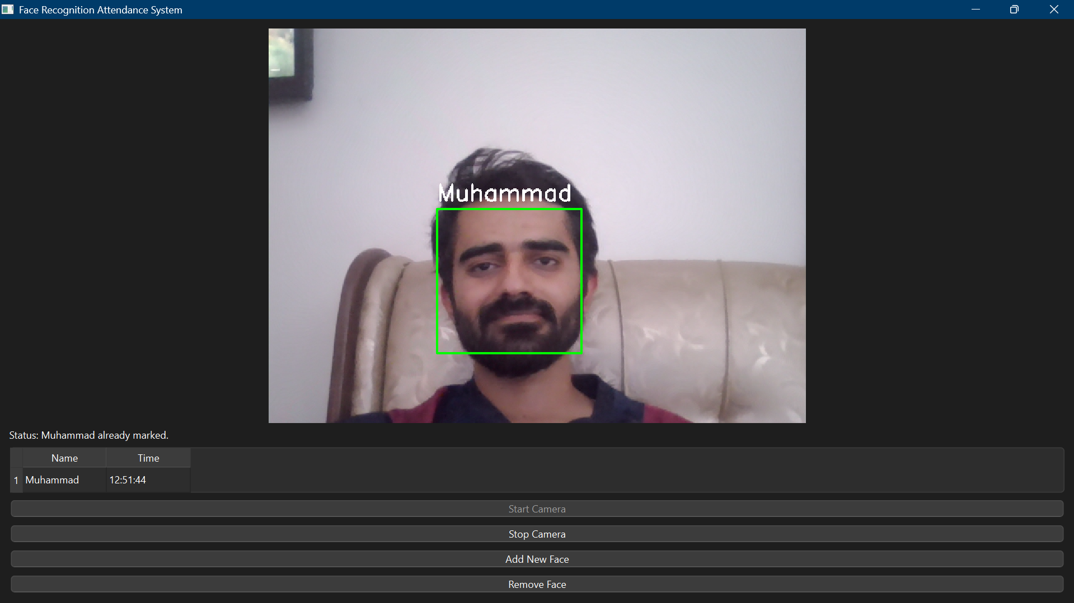

* Figure 3: Excel Attendance Sheet Output

